David_Hahner_CPRG_200_Lab3 Exception Testing:

1. Exception when save clicked with empty Reorder Level input:

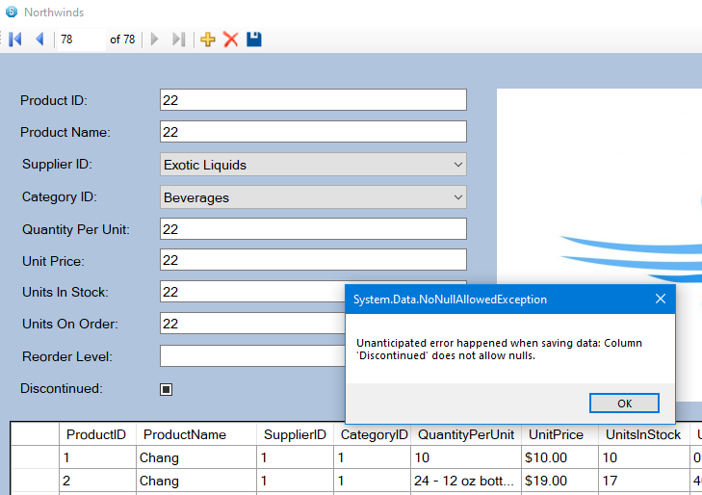

1. Exception when save button clicked when a negative value is entered into Unit Price:

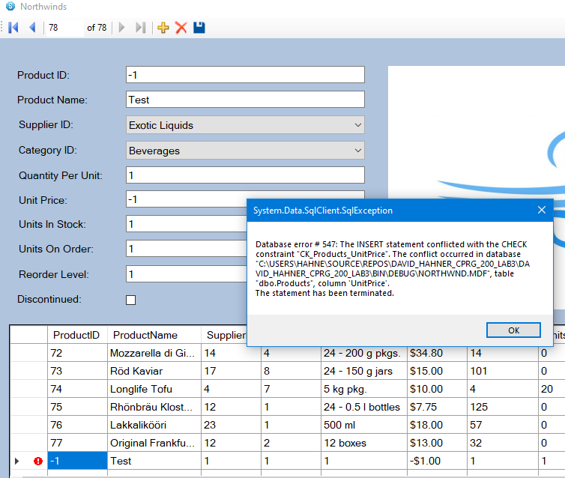

1. 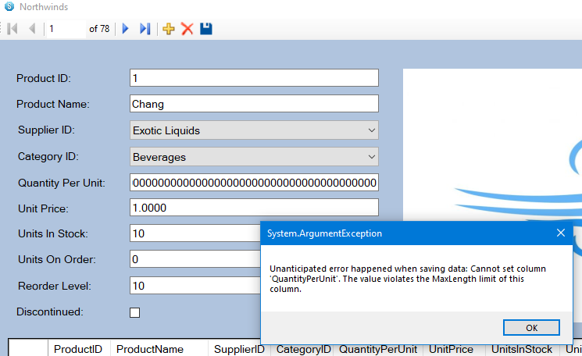Exception when save button clicked when an erroneous extended length value is entered into Quantity Per Unit:
2. Successfully added a new ProductID 86 to the table, when save clicked:

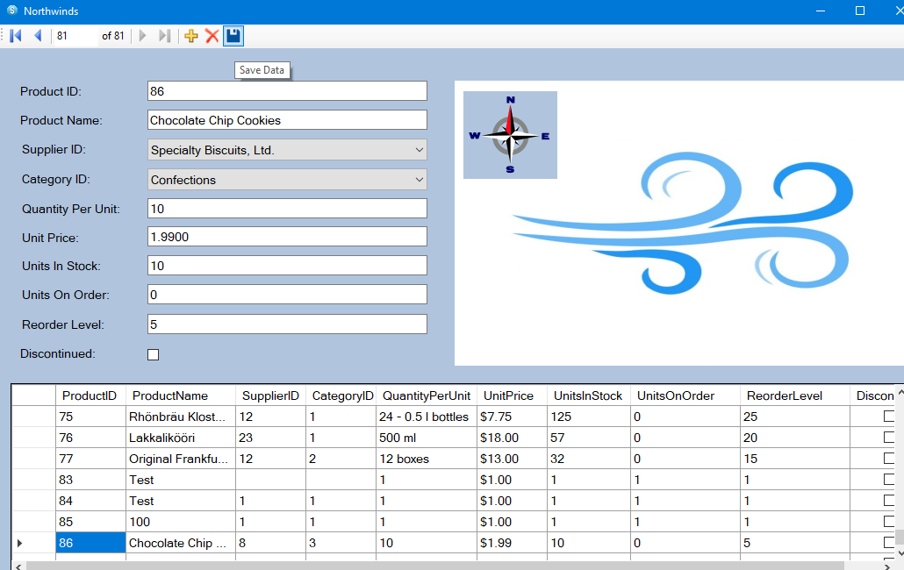

1. Successful deletion of ProductID 84:

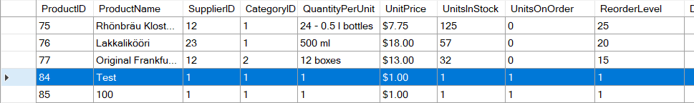Before:

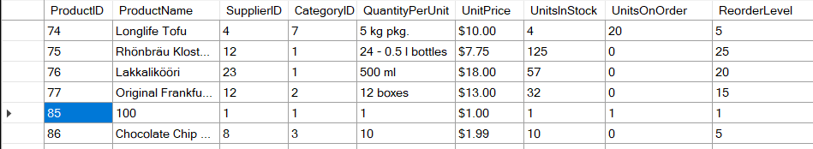After: